Group No: XX
Group Member:
- Name Surname
- Name Surname
- Name Surname
- Name Surname

Preparation
- Download “Activity 1 Resources” from MyCourseVille.
- Answer the questions in the MyCourseVille assignment and submit this file (.docx/.pdf format) and other required materials as stated in the assignment to MyCourseVille.

Part 1: Text Representation
- Open “sample_utf8.txt” in Notepad and see the content.
  - Open “sample_utf8.txt” in HexEdit.
  - Note that the first three bytes (from the address 000 - 002) are the BOM for text files encoding in UTF-8.
  - What is the UTF-8 code of the character A? How many bytes are used for the character?
(Answer in assignment in MCV)
  - What is the UTF-8 code of the white space character? How many bytes are used for the character?
(Answer in assignment in MCV)
  - What is the address of the character ข? What is its UTF-8 code?
(Answer in assignment in MCV)
  - Use HexEdit to replace the character ข with the character ง. Save the file as “sample_utf8_modified.txt”. Open it in Notepad and see whether the content of the file is correct. How to do that?
(Answer in assignment in MCV)
  - Make a screen capture showing the hex content of “sample_utf8_modified.txt”.
(Attach the screenshot to the assignment in MCV)
- Consider the following Hex content of a file.
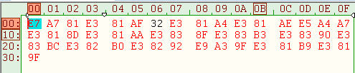
  - What is the size (in bytes) of this file?
(Answer in assignment in MCV)
  - Type in this Hex content into a new file. Save the file as “hamburger.txt”
  - Open the file in notepad. What is the content? Use Google Translate to translate the content of the file to English. What does the file say?
(Answer in assignment in MCV)

Part 2 : Image Representation

BMP Image Representation
(Use the file name: Part2.bmp in “02 Image Representation” folder)
- Use “File Explorer” to observe the file
  - What is the file size (in bytes)?
(Answer in assignment in MCV)
  - Write the file size using a 2-byte Hexadecimal Notation.
(Answer in assignment in MCV)
- Open the BMP file assigned to your group in HexEdit
  - Under the “Template” menu item, apply the template you think will help you analyze the BMP file format.
  - By observing the Hex content of the file, explain at least 2 ways to know the size of the file in bytes. Is the size similar to what can be seen from “File Explorer”? (Hint: file size showing with little endian byte order)
Here’s difference between Little Endian VS Big Endian Representation
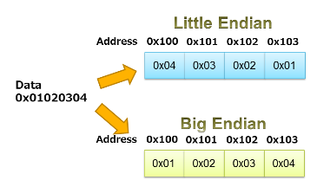

(Answer in assignment in MCV)

  - What is the dimension of the image, and how can you find it in HexEdit?
(Answer in assignment in MCV)
  - What does the content at 01C - 01D represent?
(Answer in assignment in MCV)
  - Explain how is the color of a pixel encoded?
(Answer in assignment in MCV)
  - What is the RGB value (in hexadecimal) of the color used for the background in the image file?
(Answer in assignment in MCV)
  - What is the RGB value (in hexadecimal) of the color used for the outline of the shape in the image file?
(Answer in assignment in MCV)
- Edit the Hex content of the file so that the shape is filled with a color “green” (0x00FF00).
  - Explain the steps you did in completing the filling.
(Answer in assignment in MCV)
  - Save the new image with different filename. Upload the image (both original and edited version) to the assignment in MCV.

Part 3 : Data Representation In the Memory

Introduction
- The folder “03 + Outstanding Mario Hacking” contain fceux.exe which is an NES (Nintendo’s game console) emulator.
- Execute the program. Then, open “Super Mario” ROM (Files > Open ROM). The ROM file is in the subfolder “roms”.
- If you are not familiar with the games, play the games for around 5 minutes. (Use the arrow keys for movement, ‘f’ for the ‘A’ (jump) button, ‘d’ for the ‘B’ (run,fireball) button, ‘s’ for the ‘SELECT’ button, and ‘Enter’ for the ‘START’ button.

Activity: Super Mario Hack
- While playing the games, pause the games by hitting the “Enter” key. Open the built-in hex editor. (Debug > Hex Editor). The hexadecimal numbers displayed in the hex editor is the real-time memory of the program (NES memory).
- The values at the position 0x0754 and at the position 0x0756 are known to be the data determining the “states” of Mario (short/tall, Normal Mario/Super Mario/Fire Mario).
  - Normally, Mario starts in the “Normal Mario” state (he looks short) and when he takes a “Mushroom” item, he grows into the “Super Mario” state (and he looks taller). In the “Super Mario” state, he can take a “Flower” item to go to the “Fire Mario” state in which he can throw fireballs with the “B” button.
  - When a “Fire Mario” or a “Super Mario” is hit by an enemy, he is downgraded to “Normal Mario”. When a “Normal Mario” is hit by an enemy, he dies.
  - Try changing the values in both positions to have a “short” Mario that can throw fireballs. What are the values?
(Answer in assignment in MCV)
- Now we will modify the ROM of the game. In Hex Editor window, select View > ROM File. (Hint: default is NES memory). Now try to edit the Mario character. (After editing ROM, you will need to reset. On the main screen menu, select ROM > Reset)
  - Byte : 0x05E8 = Color of Small/Big Mario's hat + outer clothing
  - Byte : 0x05E9 = Color of Small/Big Mario's skin
  - Byte : 0x05EA = Color of Small/Big Mario's hair + inner clothing
  - What’s the original value (in Hexadecimal) that represent color of Mario?
(Answer in assignment in MCV)
  - Try changing the values (in Hexadecimal) represent other color. Capture the result.
(Upload the captured image to assignment in MCV)
- Now try to edit the text on the welcome screen.
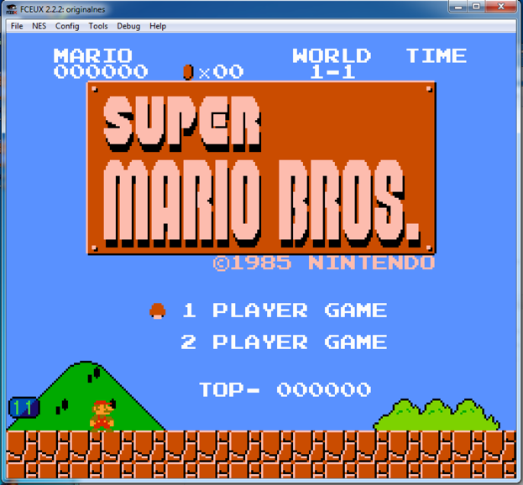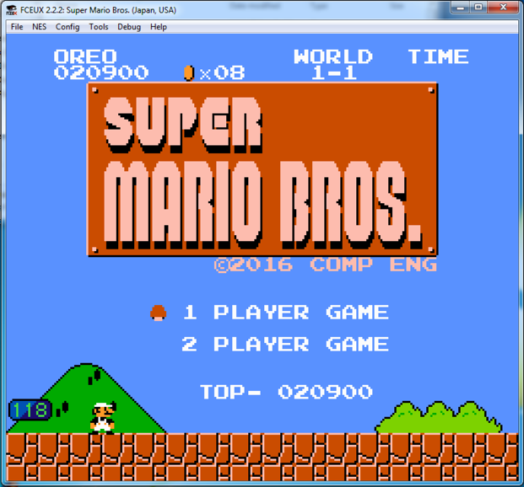
  - Bytes : 0x00765 to 0x00769 = "MARIO" text on top bar
  - Bytes : 0x0076D to 0x00771 = "WORLD" text on top bar
  - Bytes : 0x00774 to 0x00777 = "TIME" text on top bar
  - Bytes : 0x09FB5 to 0x09FC2 = "©1985 NINTENDO" text on title screen
  - Bytes : 0x09FE6 to 0x09FE9 = "TOP-" text on title screen
  - Try to edit the word “MARIO” to “LUIGI” and “©1985 NINTENDO” to “©2026 CP CHULA”. How do you do that? Also upload the screenshot to the assignment in MCV.
(Answer in assignment in MCV)

Part Outstanding (Optional) : Super Mario “Open” Hack

A Chance for the “Outstanding Factor”

Super Mario “Open” Hack

Some of the “best hack” will be awarded this week’s “Outstanding Factor”
For example, you can control the timer on the top right of the screen by changing memory at 0x07F8-0x07FA to your decided value. Try changing 0x07F8-0x07FA to 09 09 09 to get more idea.
Another example is to control your score by changing memory at 0x07D8-0x7DD to any value. Good Luck!

With the information given below, do something fun on your own. Explain the changes that you made, along with screenshots/videos/other evidence, to the assignment titled “Activity 1: Outstanding” in MyCourseVille.

Here’s the information.
===== In ROM File =====
05E0 = Background (sky) color for Overworld levels 1-1, 1-3, 2-1, 2-3, 4-1, 4-3, 5-3, 7-3, 8-1, 8-2 and 8-3.
05E1 = Background color for Underground levels 1-2 and 4-2. (Also used for New Level and Game Over screens.)
05E2 = Background color for Dungeon levels 1-4, 2-4, etc.
05E3 = Background color for Nighttime Overworld levels 3-3, 6-1 and 6-2.
05E4 = Background color for Winter Overworld levels 5-1, 5-2 and 7-1.
05E5 = Background color for Winter Nighttime Overworld levels 3-1 and 3-2 (and the cloud portion of 6-2).
05E6 = Background color for level 6-3.

===== In NES Memory =====

0024 - Fireball 1 Flag / Explosion Delay (00-01 / 80-86)
0025 - Fireball 2 Flag / Explosion Delay (00-01 / 80-86)

0030 - Point display 3 timeout
0031 - Point display 2 timeout
0032 - Point display 1 timeout

0057 - Player X Delta (Signed)

008D - Fireball 1 X Position (00-FF)
008E - Fireball 2 X Position (00-FF)

009F - Player Y Delta (Signed)

00A6 - Fireball 1 Status? (03, FD, FE)
00A7 - Fireball 2 Status? (03, FD, FE)

00CE - Player Y Position

00D5 - Fireball 1 Y Position (00-FF)
00D6 - Fireball 2 Y Position (00-FF)

0200-02FF - PPU Sprite Memory
0300-03FF - Sprite Values
03A0 - Unknown Value, Gets set to FF every time a map is loaded.

0500-05CF - Screen layout page 1
05D0-069F - Screen layout page 2

06A0 - Screen Memory Offset

06CE - Fireball Count (00-FF)

06D5 - Player Sprite Frame

06D7 - End of Level Fireworks (Firework position is determined by value)

06FC - Controller 1 Poll

0700 - Running Animation Speed (00-28)
0701 - Sliding Flag (00 - No, 01 - Yes)
0702 - Slide Length
0703 - Matches Running Animation Speed from 1C-28
0704 - Unused?
0705 - Cycles during walking animation
0706 - Minimum Jump Height (01)
0707 - Always 01?
0708 - Starting Jump Y Position (Affects max jump height)
0709 - Player Y Delta While Jumping
070A - Player Y Delta Change To
070B - Player Injured Flag
070C - Walking Frame Delay (04-07)
070D - Player Frame While Walking (00-02)
070E - ? When Not 00, Player can't move or jump
070F - ? When not 0, score at flag is visible before touched.
0710 - How Mario enters the level (00-07)
00 - Fall from ceiling - Water (2-2)
01 - Fall from ceiling - Underground (1-2)
02 - On ground (1-1) Also, pipes and vines
03 - Middle of screen for castles (1-4)
04 - Unused: Same as 01
05 - Unused: Same as 01 (maybe 02?)
06 - Unused: Same as 07
07 - On ground, Mario walks right (Between 1-1 and 1-2)
0711 - Delay (Used by throwing fireballs)
0712 - Unused?
0713 - Used during flag contact
0714 - Ducking Flag (00 - Walking, 04 - Ducking)

0747 - Object pause (When above zero, nothing but Mario can move. Used upon dieing)
0748 - Display Coins
074A - Controller 1 Poll
074B - Controller 2 Poll

074E - Bubble Flag (00 - Bubbles Visible, 01 - No Bubbles)

0754 - Tall Mario Flag (00 - Tall, 01 - Short)
0756 - Powerup Flag (00 - Mario, 01 - Super Mario, 02 - Fire Mario)
0757 - Player Lives Screen Flag (00 - Playing, 01 - Player Lives Screen)
0758 - Vine Growth Flag? Set to 1, die, restart, vine grows!
0759 - Time Up Flag (00-01) Doesn't take effect until after death
075A - Current Player Lives
075C - Display Level
075E - Display Coins
075F - World
0760 - Level
0761 - Waiting Player Lives

0770 - Gameplay Mode (00 - Demo, 01 - Playing, 02 - End of Level)
0772 - Gameplay Status (00 - Run to next status, 01 - Loading, 02 - Loading done, 03 - Playing)
0773-0774 - Counters for Gameplay Status

0778 - Affects Horizontal Scrolling
0779 - Color Mode? (1E - Color, 1F - Black & White)

077F - Delay (Used by demo, invincibility, and player lives screen)

0781 - Delay (Used by walking and throwing fireballs)
0782 - Delay (Used by jumping)

0787 - Timer Delay (00-18)

079F - Star Invincibility Timeout (00 - Not Invincible, 00-07 - Slow Flash, 08-FF - Fast Flash) - You can even kill Bowser's fireballs!

07A0 - Player Lives Countdown (00-07) At zero it starts the demo.
07A2 - Demo Countdown (00-07) At zero it starts the demo.

07ED - P1 Coins: 9x
07EE - P1 Coins: x9
07F3 - P2 Coins: 9x
07F4 - P2 Coins: x9

07FC - Beat Game Flag (00 - 1st Run, 01 - 2nd Run)

B424 - Standing Max Jump Height (20) Signed
B425 - Sliding Max Jump Height (20) Signed
B426 - Walking Max Jump Height (1E) Signed
B427 - Staring to Run Max Jump Height (28) Signed
B428 - Running Max Jump Height (28) Signed

B42B - Standing Gravity (70) Signed
B42C - Sliding Gravity (70) Signed
B42D - Walking Gravity (60) Signed
B42E - Starting to Run Gravity (90) Signed
B42F - Running Gravity (90) Signed

B432 - Standing Jump Y Delta (FC) Signed
B433 - Sliding Jump Y Delta (FC) Signed
B434 - Walking Jump Y Delta (FC) Signed
B435 - Starting to Run Jump Y Delta (FB) Signed
B436 - Running Jump Y Delta (FB) Signed

B440 - Left Running Speed Max (D8) Signed
B441 - Left Walking Speed Max (E8) Signed
B443 - Right Running Speed Max (28) Signed
B444 - Right Walking Speed Max (18) Signed

B447 - Running Acceleration (E4) Unsigned

Summary สรุปสิ่งที่ได้จากการทำ Activity นี้
- Activity นี้ หลัก ๆ ต้องการให้เข้าใจเรื่องการเข้าใจ Data representation ว่า ข้อมูลถูกเก็บยังไง แปลงยังไง สมมติหากเราเปลี่ยน Data Byte นี้ จะส่งผลอย่างไร เลย Represent ในรูปแบบตัวเกม เพื่อให้เห็นภาพง่ายขึ้นครับ
- โดยรวมหลักๆ ที่อยากให้ได้จาก Activity นี้คือเรื่องการเข้าใจพวกระบบเลขฐาน 2 (Binary System) , ระบบการแปลงเลขฐานไปมา (เช่น จาก 2 -> 8 , 8 -> 16) ประมาณนี้ครับ

รายวิชาที่มีเนื้อหาที่เกี่ยวข้องกับ Activity นี้
- 2110352 Computer System Architecture (ใช้ Concept เรื่อง Endian)
- 2110211 Introduction to Data Structure (ใช้แค่ Concept ที่ว่า จะเลือกรูปแบบการเก็บข้อมูลยังไงให้โค้ดสามารถรันได้เร็วพอ ประหยัดพื้นที่ และมีประสิทธิภาพมากพอคับ)
- 2110251 Digital Computer Logic (ใช้ Concept การทำ Operation ระหว่างบิต ซึ่งสามารถนำมาสร้างเป็น Logic Gate ต่างๆ ได้)

Spoiler for Activity 2
- จากเดิมเราสนใจระดับ Bit Byte เราสามารถจะลองในระบบที่ใหญ่ขึ้นได้ เช่น CPU ซึ่งจะได้ลองเล่น Brookshere’s Simulator ดูกันน
- ลองศึกษาเรื่องหลักการทำงานเบื้องต้นของ CPU มาเบื้องต้นได้ครับ รอ Activity ของวันศุกร์นี้ปล่อยได้เลย (23 Jan 2026)

